Muhammad Umar Farooq
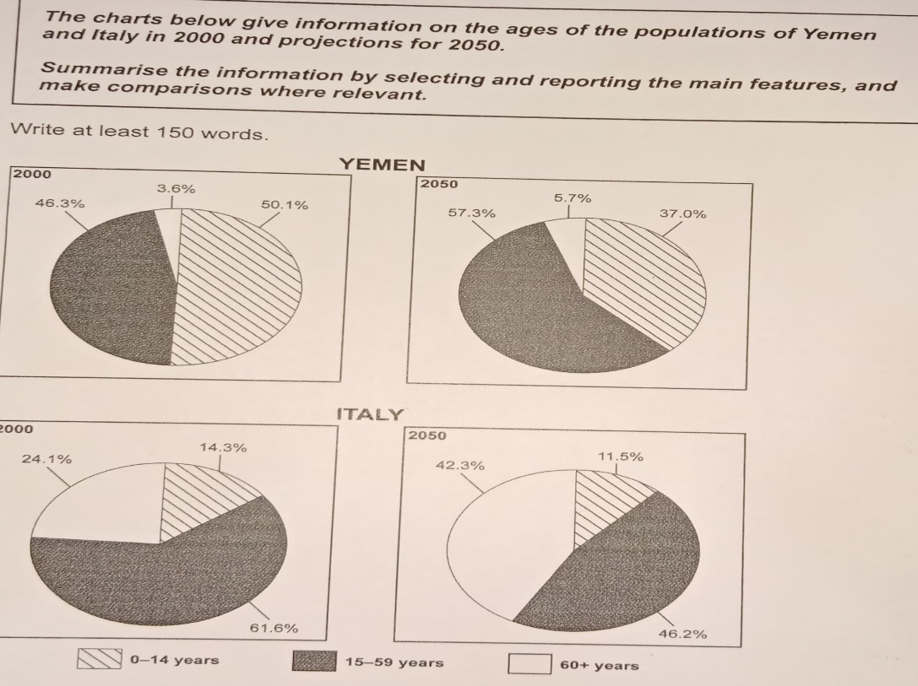
The provided charts illustrates the segments of population of two counties Yemen and Italy in 2000 and forecasting for 2025.
Overall, Yemen had half of their public belongs to the child group and predicted to increase by the next few decades while, Italy had almost less than three quarters of the public belongs to the mature age group and this will decline in future.
Looking at the details, during the time frame Yemen had 50.1% of citizens who belongs to the 0-14 age group but the figures demonstrated the decline in upcoming time. And 46.3% of Human aggregation belonged to the mature category meanwhile, this will be increase in next 30 years of period and climb at 57.3%. Sixties plus Resident cohort in Yemen had 3.6% segment in population and this showed the minimal rise in the later on.
Dive into the Italy, on the first time spam it has 60.6% of the Inhabitancy belongs to the 15-59 age group and this will decrease in future on 46.2%. About a quarter of population lives in the old age and showed the rapid increase by the later decades. The early age people had almost same trends by the both dimensions of time.
ST: 12:42
ED: 1:04

